Abstract

We have all experienced the amazing wonders of bread and I have been intrigued since a child while peering into the oven window, watching it rise. When given the opportunity to dive deeply into one key ingredient of a recipe, I quickly decided on bread.
Yeast is in fact a living organism, which is strongly attracted to simple sugars. When these two ingredients are exposed to one another, reactions such as fermentation and the releasing of carbon dioxide occur, in turn creating small bubbles in the bread that help it rise. After understanding the basic concepts of yeast, I decided to conduct a three part experiment altering the amount of yeast from half the recommended amount, the recommended amount and twice it. I wanted to see through this test how much it affected the bread on a quantitative scale, while on a qualitative scale I desired to understand which bread people preferred.
After the experiment, I learned that the density ranged from 1.22g/cm3 (534.34g in weight) in the sample with the least amount of yeast to 1.07g/cm3 (447.99g in weight) in the largest. As I anticipated, the density was highest in the sample with the least amount of yeast.
The difference between 1 ¼ tablespoons of yeast and 4 ½ tablespoons created a .15gm/cm3 difference in density and a difference in weight by 86.35grams. Though this data showed significant changes, they visually looked extremely similar and I anticipated a greater change in height although it wasn’t as noticeable as I expected.
I conducted a taste test with 12 students. This qualitative portion of my experiment, however, provided me with inconclusive results. I am not sure if it was due to a poorly structured experiment, a flawed questionnaire, reading too quickly, system error or lack of organization but there was a huge mistake in my data. Bread A was rated lowest on both taste and texture, which I assumed, given most people are used to fluffy bread. While bread C which had the fluffiest texture was rated the highest on the two categories. Shockingly, when asked their favorite bread the responses showed the biggest portion of students answered bread A, and the lowest amount selected bread C. These two different points of data offered completely different conclusions and because of this I was able to draw conclusive data from density and weight but not personal preferences.
Overall, this experiment showed me the importance of a single ingredient in a food that I use almost daily. I understood how easy it was to measure quantitative data, however measuring preferences is another thing entirely and requires much more care and consideration when creating and conducting experiments based on people’s opinions and preferences.

Introduction
Yeast is single celled fungus that rapidly produces smaller cells through the budding of fully developed cells. It is extremely attracted to sugar cells and because of this yeast is a vital ingredient utilized in beer, bread and wine. I am focusing on yeasts chief value in baking bread. Through this experiment, I am going to alter the amount of yeast in five trials. The recipe, temperature, time frame and oven will stay the same to provide consistency.

According to the article “Yeast’s Crucial Roles in Baking,” on Fine Cooking, yeast works in these three key roles. Many of us correlate bread to a light, fluffy texture and risen dough. When yeast is mixed with flour and other ingredients enzymes in the yeast create simple sugars which in turn releases carbon dioxide and ethyl in the dough. As long as more carbon dioxide fills up bubbles in the bread, the bread continues to rise. Balancing the ratio of yeast to the rest of the recipe is vital to create a perfectly risen bread.
Next, the dough itself is strengthened when yeast is added. The two proteins, flour and water combine to create gluten. A strong chemical compound which holds in the carbon dioxide gasses. While kneading the dough, more carbon dioxide is released from the yeast interaction. The longer this occurs, the more stretchy and kneaded the dough becomes, ““Yeast also produces enzymes such as transglutaminase that change the behavior of the gluten in the dough. The dough becomes less extensible as more of the enzyme is produced and more cross-linking occurs in the glutenin proteins. This strengthens the dough” (Science of Good Cooking, 158).
Lastly, yeast affects the fermentation process which alters the bread’s flavor drastically.
Fermentation is when yeast reacts with sugars present in the dough. The results include the production of the critically important carbon dioxide, alcohol and flavorful byproducts. Building blocks of bread are fats, proteins and starches. They don’t initially have very much flavor but when broken down by yeast into their key components; proteins become amino acids, starches into sugars and fats into three different flavors. When broken down, these compounds have an amazing flavor.
According to, The Science of Good Cooking, “Yeast used in bread eats sugar. There is little sugar in flour, but uncooked flour has enzymes that break down starch molecules in the grow into small sugar molecules that yeast can feed on. The enzymes start to work as soon as water is added to sugar.”
Carbon dioxide plays a vital role in the recipe, “In bread, it is the carbon dioxide that bakers are after. Alcohol is still produced, and a measurable amount of alcohol remains in the bread even after an hour of cooking at high temperature. This alcohol may help to dissolve aromatic molecules and enhance the scent and flavor of the bread, but generally you are only concerned with the amount of gas the yeast produced to make the dough into a nice light foam” (Science of Good Cooking).
Bread also holds astonishing significance to cultures across the world, especially in our society. According to a credible graph on statista.com, 98.33% of American households use bread. This study was conducted from February 4, 2014 through March 11, 2015. It had a total of 28,869 test subjects.
On a cultural note, bread has been significant since biblical times. It is eaten by members of the church during communion as a representation for rituals, the bread of life. In fact, it is even described as a universal symbol for peace. It’s roots can be found in cultures such as the Egyptians, Romans, Christianity, Vikings and Normans to name a few. It is estimated that bread has been around since 8,000 BC. In fact, in Egypt, bread was used as an equivalence to currency. (Why Eat Bread).

Bread holds remarkable merit in everyday meals, religion and culture. It is one of the most common crops and is a valuable asset to farmers. Thus, the critical ingredient of yeast is extremely important to different parts of the world and cannot be ignored during the baking of bread.
Through a series of 3 test samples, I am going to alter the amount of yeast used in the same recipe for Rosemary Sourdough Bread. This will vary from ½ the recommended amount to two times what the recipe calls for. My goal is to measure the density and height to comprehend firsthand how much change yeast can provide. I am also going to conduct taste tests. Because yeast affects the fermentation process in bread making, thus altering its flavor; I want to ask subjects about the texture, appearance and which sample they prefer on a scale. This will show the significance of processes such as fermentation which are a direct result from yeast have on the breads qualitative properties.

Methods
In this experiment, I am testing how the amount of one simple organism can alter an entire recipe. I am going to make 3 batches of Artisan Semolina Rosemary bread. However, I will alter the recipe so I may measure density and weight as the quantitative results.
The only independent variable is yeast. I am keeping the recipe exactly the same. This means there will be 2 cups of all purpose flour, 1 tablespoon of organic sugar, 1 ½ tablespoon of all purpose salt, 1 ¼ of tap water at the same temperature and sink, 1 tablespoon of organic olive oil, 1 cup of semolina flour, 1 tablespoon of rosemary leaves from the same garden bush, and 1 tablespoon of cornmeal.
I will also be using the same measuring cups for consistency, oven and oven temperature at 400 degrees. After making the dough all 3 loaves will be tightly refrigerated for 4 hours in the same spot of my fridge. This is to ensure they will all be at the same distance away from the cooler. Finally, each loaf will be cooked for exactly 25 minutes. I will allow them to cool for 1 hour before measuring their quantitative properties.
The only variables of my experiment are density(d) and height(h). These factors will change as a result of the varied yeast levels. The first experiment will have half a package of yeast, 1 ⅛ tablespoons. The second will have 2 tablespoons. The third, one package, 2 ¼ tablespoons. The fourth will have 2 ½ tablespoons. Finally, the last loaf will have two packages of yeast, 4 ½ tablespoons.
In order to measure the quantitative qualities, (d) and (h), I will have to use the following equations. To find the density of each loaf, I will first have to find the mass. The mass of an object is how much matter is inside of an object. Next, volume, which is the amount of space an object occupies. The mass will be divided by the volume to find the density. Density is the degree of compactness of a substance. Thus, telling me how dense and compact the bread is. I expect the loaf with the least amount of yeast to have high level of density.
I will also be measuring and comparing the height of the loaves. This will show me how much they rise or fall as the yeast levels fluctuate.
I am going to analyze qualitative results through finding the average preferences from the taste tests. I will find the density of the bread using the method, water displacement. This works because one mL of water is equivalent to one cm^3.
The significance of this experiment is to comprehend how the various amounts of one living organism (yeast) can alter a recipe. I bake often at home and am extremely interested to see to what extent yeast changes the taste and density of something I eat regularly.

preferences
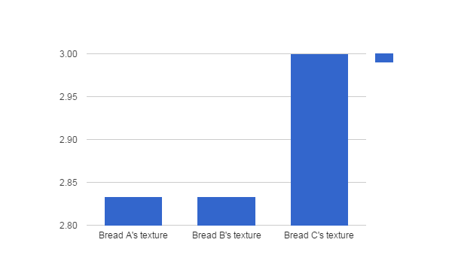
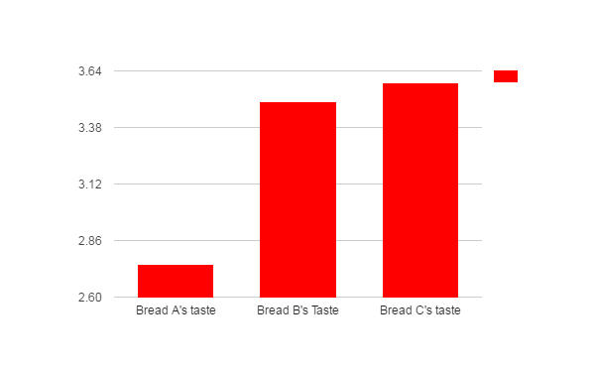
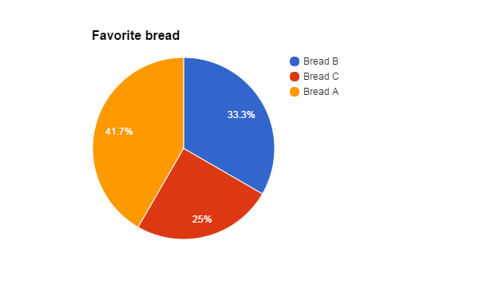

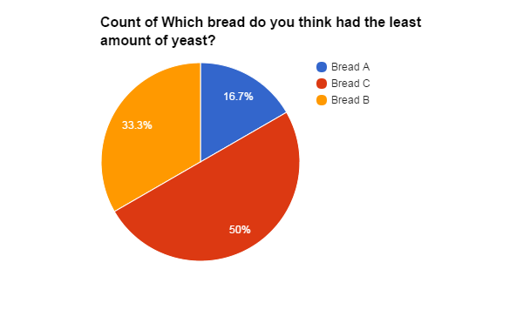
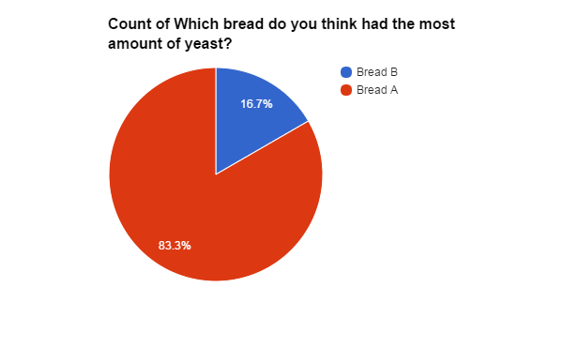

 | Bread A | Bread B | Bread C
Density | 1.22g/cm3 | 1.15g/cm3 | 1.07g/cm3
Weight | 534.34g | 458.54g | 447.99g

Results

My test offered insight into data covering both qualitative and quantitative properties of bread. Bread A had the smallest amount of yeast, ½ the recommended amount and had a density of 1.22 g/cm3 and a weight of 534.34 grams. It was an extremely compact sample and didn’t have the fluffy quality that is associated with bread.
Bread B was the one with the recommended amount, yet rated highly on taste but very low on texture. It’s density was significantly smaller than that of bread A’s, being 1.15 grams per cubic centimeter, but didn’t rise as much as bread C, which has double the amount. Bread C was of course the smallest density at 1.07g/cm3 and weighed 447.99 grams.
By measuring the density and weight with a cubic scale, I was aware of how the breads physical structure changed with 3 different levels of yeast. I saw the numbers but I think the realization clicked more while observing the final product and holding it in my hands to realize just how much or little density it had.
On the qualitative spectrum, when I conducted the taste test, both bread A’s texture and taste had the lowest ratings while bread C’s taste and texture were exceedingly high ratings. Bread B, which was actually the recommended amount had a low rating on texture but a high one on taste.

Discussion

Overall, I am not very confident with my taste test which provided qualitative results. On the survey, bread C had the highest ratings for taste and texture, both close to 100%. Bread C had the largest amount of yeast, double times the normal amount and therefore was less dense than the other samples. It had the fluffiest texture. What confused me, however, is that majority of students voted that this was their least favorite bread despite giving it the highest ratings in taste and texture.
Bread A, on the other hand, was the most dense. It was quite clear to my surveyor's this sample had the lowest amount of yeast. When asked, a huge percent of 83.3 of the class guessed sample A. This showed me how obvious the results were when there was a small amount of yeast.
As I assumed, students gave this bread an extremely low rating. When asked about it’s texture and taste, it received the lowest scores. What truly astonished me yet again was that sample A was overall the students favorite bread coming in at 41.7%.
This data was confusing and inconclusive because it contradicted itself. I am not sure if the questions were confusing and students answered them wrong or if there was some type of system error. However, there can be two very different conclusions from my data thus I am not confident with it’s results.

My quantitative results however, were very clear and identifiable. I was able to draw conclusions from their data and there wasn’t as much room for error. Bread A was the most dense, and had a weight of 534.34g and a density of 1.22g/cm3.
Bread B was exactly in the middle of the other two breads densities, having one of 1.15g/cm3 and a weight of 458.54g.
Finally, bread C retained a very light density of 1.07g/cm3 and a weight of 447.99g.

These results showed me with clear data that the density ranged in breads from .15g/cm3 and varied in weight by 86.35g. It was obvious that as the amount of yeast increased, the density and weight also increased.

Overall, I am not extremely satisfied with my results. I would have liked to re do it, creating a more precise questionnaire and labeling the bread accurately. One source of a problem could have been that students from other classes were trying it and when they got back to their own classrooms could have forgotten which sample was which. For more precise data, I should have kept the students in the room until they answered it and created a survey that was more clear as to what it was asking.

Conclusion
I have found this research to be extremely interesting for various reasons.
First of all, there can never be a definite answer in cooking, which is the best etc. Though a recipe can be evaluated on quantitative and qualitative questions, everyone’s opinions are very diverse and different. When talking to students, I found out quite a few of them actually really enjoyed the dense texture of bread.
Though I can alter the amount of yeast in the bread recipe, it can never be proven the best but altered to the mass majority’s preference, which is exactly what companies and distributors of food do. Catering to the masses is the most successful option.

That being said, I found the entire process very interesting. Yeast’s importance is so profound in bread making. The fluctuation I created with different amounts of yeast proved how significant it altered the bread in it’s weight and density. Understanding that it has a rippling effect in the entire recipe was vital in my comprehension. Even though recipes only call for a package of yeast in the entire loaf of bread, just a few tablespoons, this living organism creates multiple processes such as fermentation and the releasing of carbon dioxide. Without yeast, the chain of reactions necessary to cause a rise in the dough wouldn’t happen. It’s chemical structure would be completely and entirely changed.

It is of course important to understand the chemistry of your food on a basic level, or at the very least why one vital ingredient holds significance. However, while conducting this experiment I found once I had a base understanding, I preferred altering the amount of yeast to my choosing. Taking my knowledge of this project, I found the levels of yeast in a few different recipes that work best with me, and not just the mass majority.

Resources
http://www.statista.com/statistics/279972/us-households-consumption-of-bread/
http://www.lewisbakeries.net/why-eat-bread
http://www.bettycrocker.com/recipes/artisan-semolina-and-rosemary-bread/23eccc6f-3e9f-4a77-82ae-930edec2e245

